Baby Basics Northampton Starter Pack Referral Form

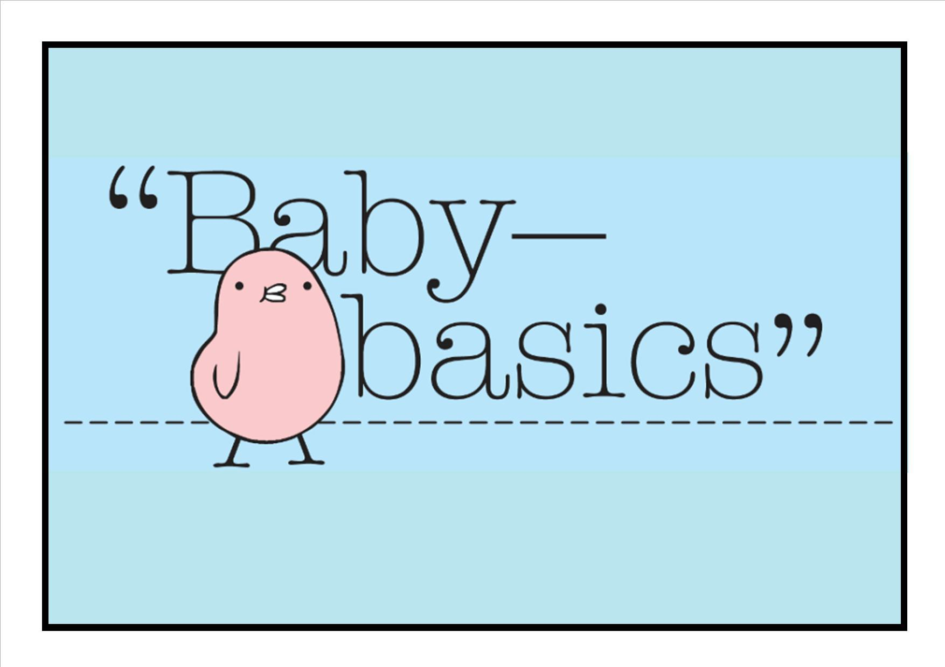
* Date Referral Received: Click or tap to enter a date.

Completion Date: Click or tap to enter a date.

* GDPR Consent: ☐ Yes (please tick)

All fields with * must be completed

Referral Details:

* Referral From: Click or tap here to enter text.  (e.g. midwife / health visitor) | * Contact Name: Click or tap here to enter text.
* Contact Telephone No(s): Click or tap here to enter text.

*Contact Email Address: Click or tap here to enter text.

*Organisation / Agency Address: Click or tap here to enter text.

*Expected Due Date: Click or tap to enter a date. | *Gender: ☐ Boy ☐ Girl ☐ Neutral (please tick correct box)
*Items required: ☐ Moses Basket Starter Pack ☐ Bath Starter Pack ☐ Other(s) (please list below)

*Additional items require: Click or tap here to enter text.
Starter pack to be collected from (please tick): ☐ Kettering ☐ Wollaston ☐ Far Cotton ☐ Central Team

Details on the mum to be: Please provide the following details on the mum to be

*Initials: Click or tap here to enter text. | *Ethnic Origin:Choose an item.
*Date of Birth: Click or tap to enter a date. | *Age: Choose an item. | *Area: Choose an item.
Reason for using Baby Basics Northampton: Click or tap here to enter text.

--------------------------- Please email your completed form to bbnreferrals@gmail.com ---------------------------------

Details below to be completed by Baby Basics Northampton ONLY

Starter Pack Checklist: Please tick the items included in the Starter Pack. If the item is not on the list, please provide the details of the product in Other(s).
Moses Basket New Moses Basket Mattress Fitted Sheets Blankets Towels Muslins Sleeping Bag Bibs Socks Shoes Hats Mittens Vests Baby Grows
Coats/Jackets Clothing Snowsuit (winter only)

Toiletries / items for Baby (all toiletries are brand new only):
Baby Shampoo Baby Wash/Soap Baby Bath Baby Lotion Sponge Nappies Toys
Toothbrush/Paste Baby Wipes Nappy Sacks Cotton Wool Nappy Cream (expiry date: __/__/__)
If required: Steriliser Bottles Bottle Brush Sterilising Tablets (expiry date: __/__/__)

Toiletries / items for Mum (all toiletries are brand new only):
Shampoo/Conditioner Shower Gel/Soap Hand Wash Breast Pads Tissues
Maternity Towels/Sanitary Towels Toothbrush/Paste Chocolates (expiry date: __/__/__)
Northamptonshire Fire Service Home Safety Leaflet Baby Basics Disclaimer Postcard

Other(s): ___________________________________________________________________ Continue overleaf if required

)

Starter Pack Collection: Date Starter Pack Collected: ____/____/____ Starter Pack No: _________

All items provided from Baby Basics have been donated by members of the local community and are sorted/ packed by our team. If you are ever unsure about the suitability or safety of any items given by Baby Basics, please do not pass onto your client. Please discuss any concerns you may have with the Team.

Collected by: ______________________________ Signature: _________________________________

Completion Update the Completed Starter Pack Spreadsheet Update the Baby Basics Database

