Northamptonshire

Carers

E-Newsletter

Anne Goodman Centre for Carers

2020 saw the sad death of Anne Goodman, one of Northamptonshire Carers founder members.
Anne served as Chair of the Trustees for many years before handing over the baton and becoming our President, working right up until months before she died.

Our office was closed for 9 months for a major refit after massive flood damage and we had the pleasure of hosting Anne's grandchildren at the Carers Centre to rededicate it in memory of the tremendous work Anne achieved over the years championing Carers and Carers issues.

We all miss her tenacity, wit and spirit.

The legacy she has left us with is beyond the scale

Please watch the small video of Sally Jones, Chair of Trustees and Anne's Grandson Ross formally opening the Centre

Northamptonshire SEND and Local Offer for Parent Carers

The Local Offer was established in 2014 when the statutory duties on local authorities to develop and publish a Local Offer were defined in the Special Educational Needs and Disability (SEND) Code of Practice (updated 2015).

This Code of Practice describes that local authorities must set out the support they expect to be available for local children and young people with special educational needs (SEN) or disabilities. This has to be available online and make arrangements for those without access to the internet.

Full details of the full article can be found on our WEBSITE

Meet Catherine 'Our Hero'

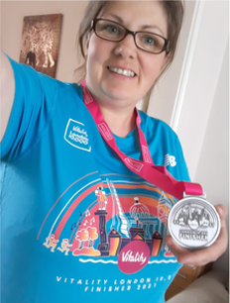

Hi, I am Cat, from Northamptonshire Carers, my role is Senior Transitional Young Adult Carer Worker.

On October 3rd 2021, in less than a year from when I started running, I will be completing the London Marathon (26.2 miles!!) virtually in my local area.

I will be running a route around Rushden, Higham Ferrers and the Greenway on Sunday 3rd October, so if you are in the area and you see me, please cheer me on.

I'll need all the motivation you can muster.

If you have got trainers on, join me to run a mile or two to help me on. Or later in the day I may be walking as I am not that fast!! I am determined to complete this task and my expected time is 6-8 hours (I don't know how I'll get through the last few miles but hopefully knowing I'm raising money for Carers will be enough.

If you would like to donate to my effort, please do, or share my page for others to read my story and donate.

You can find me HERE

The Picture above is me recently after i had run 10k with some of the Young Adult Carers and staff

A Message to Cat from her Colleagues:

Good Luck Cat, we will be there to cheer you on, we know what completing this task means to you and we love you for all of your hard work and dedication.

SENDS 4 Dads

Just a reminder to 'Dads' out there with children who have Special Educational Needs of this group designed with you in mind, they have regular meetings, a Facebook Page and a WEBSITE

Northampton General Hospital Listening Event

Some of you who support people with Learning Disabilities may wish to attend this event being run by Northampton General Hospital by Patient Experience, open to Carers as well.

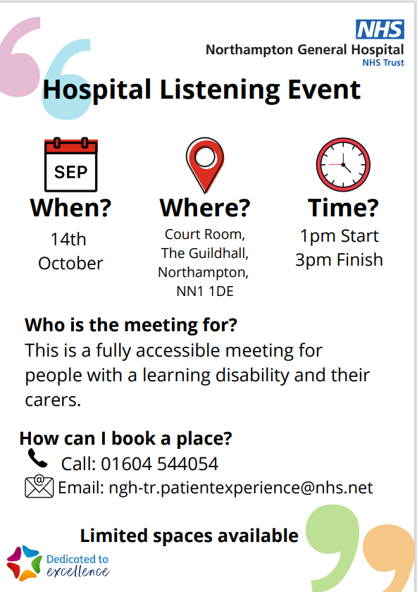

Regular Carers Groups

The vast majority of the regular Carers Support Groups, Drop-In's and Cafes are all back up and running across the county.
We have continued with some of the on-line groups for the time being to try and accommodate as many of you Carers as possible.

To find your nearest group or activity, they are listed on our WEBSITE or call the office on 01933 677907, option 1 for details

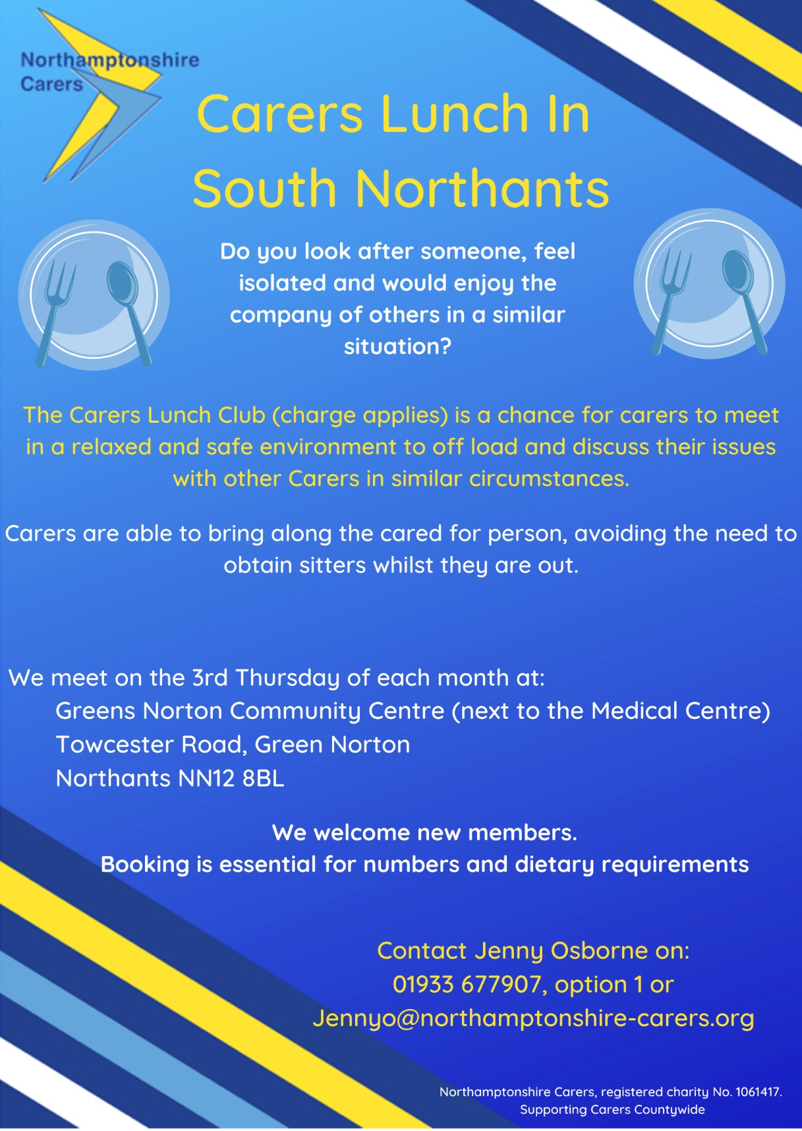

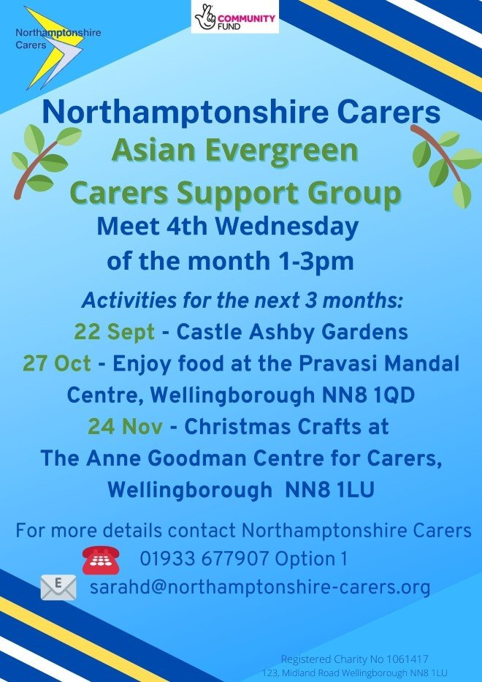

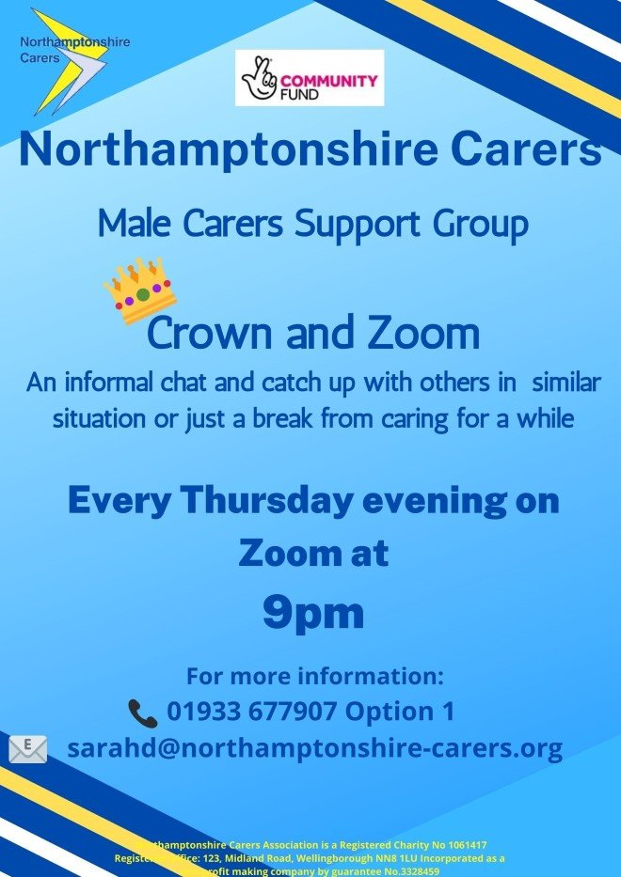

Carers Support Line

Carers Support Line Opening hours:
Mornings 9am - 12 noon
Afternoons 1pm - 4pm
Monday - Friday.

An answer phone is in operation outside of these times, please leave a message with your number and we will return your call.
We are there for information and advice as well as just someone to talk to for emotional support and a listening ear.
You are not alone - call us on 01933 677907, Option 2

Community Lotteries

We are registered with 3 of the local Community Lotteries, these Lotteries ensure that local money supports the local communities.
You don't need to live in the area to play so if you play the Lottery, we ask if you would consider supporting our organisation?

Corby - Click here
Daventry - click here
Northampton - click here

If you do gamble, we ask that you do so responsibly

Contact us Monday - Friday 9am - 5pm
Office & Carers Support Line: 01933 677907
Email: carers@northamptonshire-carers.org
Website: www.northamptonshire-carers.org
Fundraising donations: www.localgiving.com/northampotnshire-carers

CNorthamptonshire Carers is incorporated as a non profit
Company Limited by Guarantee No. 3328459
Registered Charity No. 1061417

