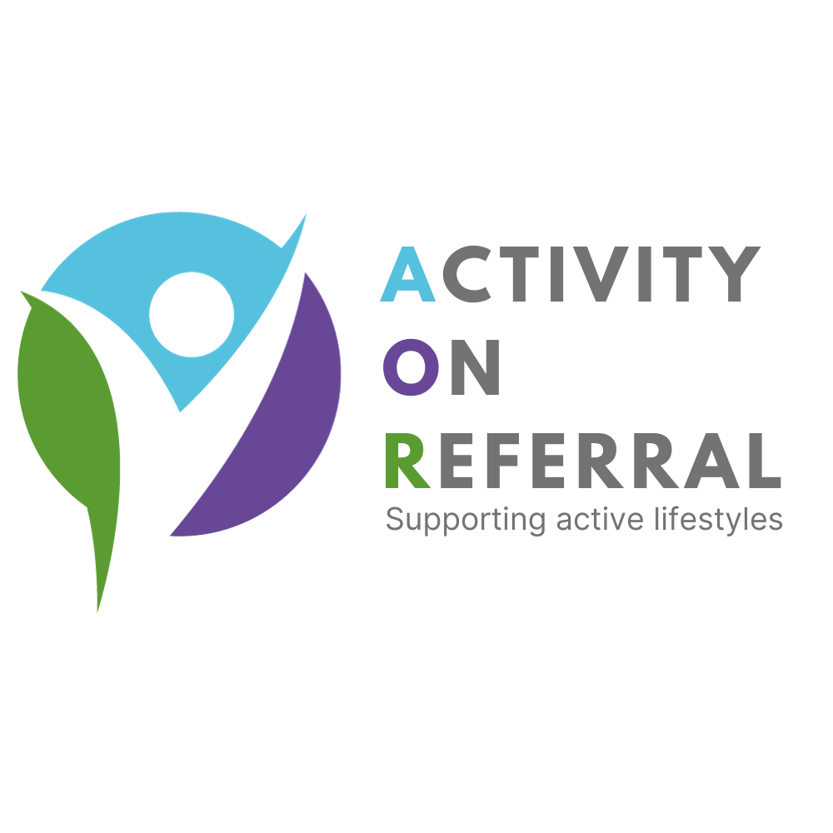
Completed form to be emailed to
nccg.aor-trilogy@nhs.net
ACTIVITY ON REFERRAL FORM

Patient Information
Name………………………………………………………................. Sex: Male ◻ Female ◻

Tel No:………………………………………………………………… Email……………………………………………………………………

Referral Information

Overweight/Obesity BMI >30 or >28 with co- morbidities ◻ Asthma ◻

COPD/ Pulmonary (lung related) ◻ Stable Angina (Controlled & stable for 6 months) ◻

Diabetes - Type I ◻ Type II ◻ Impaired Strength or Mobility ◻

Moderate cholesterol > 6.5mmol/1 ◻ Mild Depression/Anxiety/Stress ◻

Controlled hypertension (>160/100 mmhg) ◻ Neurological (Parkinson’s / MS) ◻

Smoker attempting to quit ◻ Back pain (Not acute) ◻

Current Medication  Please check for contraindications for physical activity | Additional Information  Any relevant medical conditions? (E.g. mobility or cardiac problems etc) or any specific activities/exercise that would be inappropriate for this patient.

Referrers Information

I refer this patient to the exercise referral scheme under the agreed terms and conditions

Medical Practice: ……………………………………………………………….

Patient Informed Consent

The scheme has been fully explained to me I would like to participate in the scheme to increase my physical activity levels. I therefore give consent for my personal information and relevant clinical information about my health to be passed to the AoR Qualified Exercise Professional at the AoR Accredited Leisure Facility of my choice (tick below).

The information provided on this form will only be used as part of the AoR Scheme to ensure that the scheme is delivered within guidelines of the County Standard Protocol. All personal data will be stored securely.

Patients consent given YES ◻ NO ◻ Date:…………../……………../…………

Please tick the patients preferred site to hold the initial consultation meeting:

Danes Camp LC ◻ Lings Forum LC ◻ Mounts Baths LC ◻ Duston Sports Centre ◻
Clannell Road, Western Favell Centre Upper Mounts Cotswold Avenue
Northampton, Billing Brook Road Northampton Northampton
NN4 0RX Northampton NN3 8UR NN1 3DN NN5 6EX

Completed form to be emailed to nccg.aor-trilogy@nhs.net

